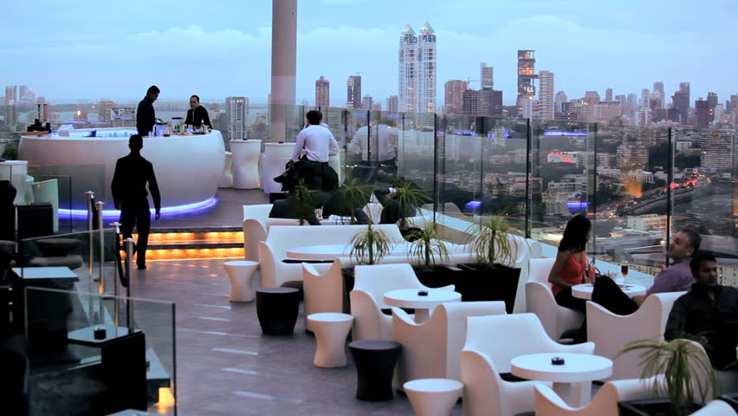

The Battle of Mumbai Neighborhoods

For Next Chinese Restaurant

By

Ziauddin Syed



Contents

The Battle of Mumbai Neighborhoods 3

For Next Chinese Restaurant 3

Introduction & Business Problem 3

Problem Background 3

Problem Description 3

Target Audience 5

Success Criteria 5

Data 6

Mumbai Neighborhood Data 6

Population Data Base 6

Accessibility of the neighborhood 7

Total Number of Restaurants 7

Methodology 8

Exploratory Data Analysis 8

Clustering of Neighborhoods 12

Results 14

Discussion 15

Conclusion 15

|  |
| --- |
| The Battle of Mumbai NeighborhoodsFor Next Chinese RestaurantIntroduction & Business Problem**Problem Background** **Mumbai**, formerly **Bombay**, city, capital of [Maharashtra](https://www.britannica.com/place/Maharashtra) state, southwestern [India](https://www.britannica.com/place/India). It is the country’s financial and commercial center and its principal port on the [Arabian Sea](https://www.britannica.com/place/Arabian-Sea). Located on Maharashtra’s coast, Mumbai is India’s most-populous city, and it is one of the largest and most densely populated urban areas in the world.  Mumbai, long the center of India’s cotton textile industry, subsequently developed a highly diversified manufacturing sector that included an increasingly important information technology (IT) component. In addition, the city’s commercial and financial institutions are strong and vigorous, and Mumbai serves as the country’s financial hub  Mumbai's business opportunities, as well as its potential to offer a higher [standard of living](https://en.wikipedia.org/wiki/Standard_of_living_in_India), attract migrants from all over India, making the city a [melting pot](https://en.wikipedia.org/wiki/Melting_pot) of many communities and [cultures](https://en.wikipedia.org/wiki/Culture_of_India).  The market in Mumbai is highly competitive. It is highly developed city and hence cost of doing  business is also one of the highest. Thus, any new business venture or expansion needs to be analyzed  carefully. The insights derived from analysis will give good understanding of the business  environment which will help in strategically targeting the market. This will help in reduction of risk and the Return on Investment will be reasonable. Problem Description Running a restaurant is more than just offering food in exchange for money. One is offering an experience to customers based on items such as the decor, food, and service. As the owner, one must determine the type of experience one wants to give customers. Even after one has decided on the type of restaurant, one needs to make sure there is a market for it, the concept is within budget, and find the right location. **In this report we will be using the data science way to find the best possible location in Mumbai for opening a Chinese restaurant.**  Keeping in line with Mumbai’s cosmopolitan atmosphere the scene for dining and eating out in Mumbai is fabulously all-inclusive. The city has an extensive range of fine restaurants serving Indian, French, Italian, Chinese, Thai, Japanese, Lebanese, Arab and Mexican food. The best restaurants of Mumbai run the gamut from top of the line elegant establishments with the finest selection of wines to family style restaurants to shacks and roadside vendors and stalls. Whatever may be your preference, whoever you are, whatever your wallet size, Mumbai is sure to adapt to your requirements. Thus, one can see that the restaurant market in Mumbai is very competitive and to open a new restaurant and survive in Mumbai it is important to strategically plan the whole process especially selection of location for the new restaurant. Various factors play an important role in the selection of a location for a new restaurant:   1. Visibility   You may have found the cutest, quaintest location for a restaurant in a historic downtown somewhere, but if you’re tucked in a side street with little foot traffic, unless you have amazing marketing tactics, you may have the most Instagram- and Pinterest-worthy space with zero customers:   * + Foot fall   + Car traffic  1. Parking   Whether you’re opening fine dining or a popular chain, make sure the land you rent or buy is big enough to accommodate parking for your hungry clientele.   1. Space Size 2. Crime Rates   Crime rates are unglamorous considerations, but if you place your restaurant in a crime-laden area, are your target customers going to visit? High crime rates can make potential customers uncomfortable, and if they feel they’ll be mugged walking to their cars, it will only drive away business, no matter how legendary your coq au vin.   1. Surrounding Businesses and Competitor Analysis   You’ll want to do your research surrounding businesses. Are they doing well? Is the area affluent? Is there enough room for your business? Also, you’ll want to know what types of restaurants do well in the area; however, you don’t want to open a pizzeria if there are four in the area. Areas can only support so many of the same type of restaurant. What will distinguish any new restaurant is excellent service and consistently wonderful food.   1. Accessibility   There’s a reason that major restaurant chains are often located near highway exits: It makes them accessible for customers. Certain restaurants can get away with food or service that isn't the best simply because their locations are so accessible, like restaurants near the Eiffel Tower or Coliseum. There is plenty of foot traffic in urbanized areas, and restaurants only need to attract customers from the street into their business. Most successful restaurants—other than the truly elite—are easy to find, and you will find them in city centers or unique locations throughout the world.   1. Affordability   Cost is always a bottom-line consideration for any business. If the rent or purchase of the space is more than you’ll bring in each month in profits, that location is not feasible at that time. However, if you know that you’ll generate business from that location, then you might consider it, but you’ll need to be able to afford the upfront costs before you turn profits. Although some risks do pay off, you don’t want to be at the point where you’re struggling to cover basic costs. A killer location won’t make up for driving your restaurant out of business.   1. Safety 2. Population Base   Are there enough people in the area to support your business? There need to be enough people who live in or pass through the area regularly to keep you busy   1. Style of operation   Is your operation going to be formal and elegant? Or kicked-back and casual? Your location should be consistent with your particular style and image. If your business is retailing, do you want a traditional store, or would you like to try operating from a kiosk or booth in a mall or a cart that you can move to various locations?   1. Proximity to other businesses and services   Take a look at what other businesses and services are in the vicinity from two key perspectives. First, see if you can benefit from nearby businesses--by the customer traffic they generate--because those companies and their employees could become your customers, or because it may be convenient and efficient for you to be their customer.  Second, look at how they'll enrich the quality of your company as a workplace. Does the vicinity have an adequate selection of restaurants, so your employees have places to go for lunch? Is there a nearby day-care center for employees with children? Are other shops and services you and your employees might want conveniently located?   1. Utilities and other costs   Rent composes the major portion of your ongoing facilities expense but consider extras such as utilities--they're included in some leases but not in others. If they're not included, ask the utility company for a summary of the previous year's usage and billing for the site. Also find out what kind of security deposits the various utility providers require so you can develop an accurate move-in budget; however, you may not need a deposit if you have an established payment record with the company.  If you must provide your own janitorial service, what will it cost? What are insurance rates for the area? Do you have to pay extra for parking? Consider all your location-related expenses and factor them into your decision.  **And the list can just go on….** Target Audience The report would be beneficial to anybody who would like to open a Chinese restaurant in the city of Mumbai. The objective is to find and recommend a neighborhood in Mumbai where a new Chinese restaurant can be started. Success Criteria Based on Mumbai city data that is freely available the recommendation will be based on following factors that have been listed above:   1. Accessibility of the neighborhood. 2. Population Base of the neighborhood. 3. Number of restaurants (all inclusive) in the neighborhood. 4. Number of Chinese restaurants in the neighborhood.  DataMumbai Neighborhood Data Mumbai city is divided into regions in various ways based on different administrative requirements like municipal wards, assembly constituencies, etc. However, our requirement for population base is met by the assembly constituency division population data for any other division is not available freely. The data for constituency, hereby referred as neighborhood, will be collected as follows:   1. Neighborhood List will be scrapped from <https://en.wikipedia.org/wiki/List_of_constituencies_of_the_Maharashtra_Legislative_Assembly> 2. Neighborhood latitude & longitude data will be obtained from the google API <https://maps.googleapis.com/maps/api/geocode/json?address>   The header of data obtained is as in figure 1.    **Figure 1** Population Data Base Total population for each neighborhood is not available freely. However, for each constituency total registered voters (age 18 years and above) is available and this can be used as a proxy for the total population. This data can be obtained from Wikipedia using the link [https://en.wikipedia.org/wiki/<Constituency Name>_(Vidhan_Sabha_constituency)](https://en.wikipedia.org/wiki/%3cConstituency%20Name%3e_(Vidhan_Sabha_constituency)) and using the 2014 election data. For eg. data for Mahim constituency can be scrapped from the link: <https://en.wikipedia.org/wiki/Mahim_(Vidhan_Sabha_constituency)>. See Figure 1 above for the data. Accessibility of the neighborhood Accessibility of a neighborhood can be determined by the average of visit counts of places of interests in the neighborhood. This data can be obtained from **foursquare.com** using the API <https://api.foursquare.com/v2/venues/> and using the **stats** data from the result. The header of data obtained is as shown in figure 2    **Figure 2** Total Number of Restaurants The total number of restaurants can be obtained from **foursquare.com** using the API <https://api.foursquare.com/v2/venues/explore>? categoryId= 4d4b7105d754a06374d81259 . Total Chinese restaurants can be filtered from this data. The header of data obtained is as shown in figure 3.    **Figure 3** Methodology The methodology for the process is as follows:   1. Collect data from the sources mentioned in the data section 2. Load data into pandas dataframes for exploratory analysis 3. Do exploratory data analysis to get insights into data as to:    1. Find category wise restaurant total to ascertain how are Chinese restaurants placed against other categories number wise    2. Plot all restaurant total and Chinese restaurant total neighborhood wise, Chinese restaurant total and visit counts neighborhood wise. This will give an idea of probable location for opening a new Chinese restaurant 4. Aggregate and merge all the dataframes into one dataframe. 5. Use K-means clustering to get the best neighborhood group for opening Chinese restaurant.  Exploratory Data Analysis |
| Explore Mumbai’s neighborhood on a map Mumbai’s neighborhood data is scrapped from the links mentioned in the data section and stored in dataframe as shown in figure 1. Let’s plot this data on a map as follows:    **Figure 4: Mumbai Neighbourhood** Explore Restaurant Counts In following figure one can see that in the case of authenticate cuisine restaurants, Chinese restaurants are most popular after Indian restaurants.    **Figure 5: Restaurant Counts** Explore Total Restaurant Count v/s Total Chinese Restaurant Count Let’s explore Neighborhood wise Total Restaurant Count and Chinese Restaurant Count. Neighborhoods with less than 2 Chinese restaurant counts have been explicitly labeled. These neighborhoods could be candidates for opening next Chinese restaurants.    **Figure 6: All Restaurant v/s Chinese Restaurant** |

From the map in figure 5, one can see that Worli (Tot. Rest.37 Chinese 1), Ghatkopar East (Tot. Rest.25 Chinese 0) and Goregaon (Tot. Rest.31 Chinese 1) seem to be good candidates for opening next Chinese restaurant as they have good amount of other kinds of restaurants indicating a good amount of eating-out crowd and have 0 or 1 Chinese restaurants.

#### Explore Chinese Restaurant Count v/s Average Visit Count

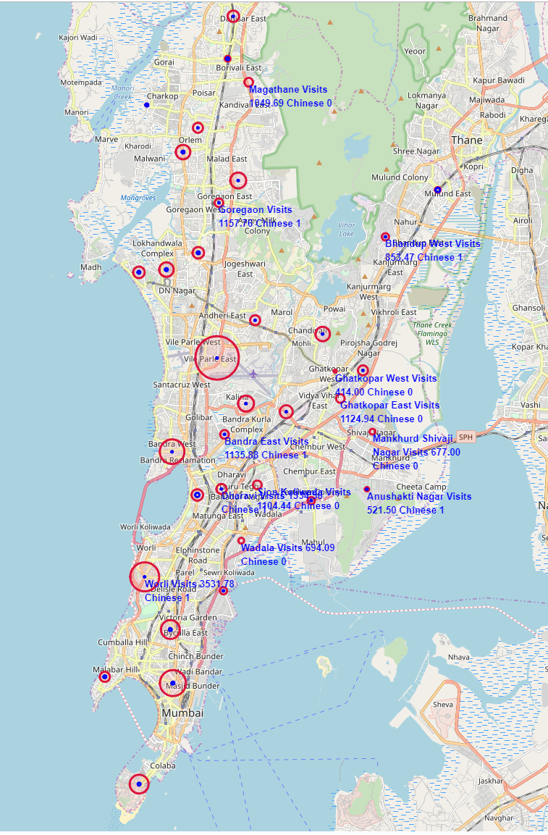

**Figure 7: Chinese Restaurant Count v/s Average Visit Count**

From the map in figure 7, one can see that again Worli (Avg. Visit Coun:3531.7, Chinese 1), Ghatkopar East (Avg. Visit Coun:1124.94 Chinese 0) and Goregaon (Avg. Visit Coun:1157.7 Chinese 1) seem to be good candidates for opening next Chinese restaurant as they have good visit counts indicating a good amount of crowd visiting places in the neighborhood and have 0 or 1 Chinese restaurants.

### Clustering of Neighborhoods

Let’s cluster the neighborhood data created to get the set of neighborhoods that would be ideal for opening the next Chinese restaurant. K-mean clustering algorithm will be used to cluster the neighborhoods. The final data after merging data sets described in the data section is as shown in the figure 8

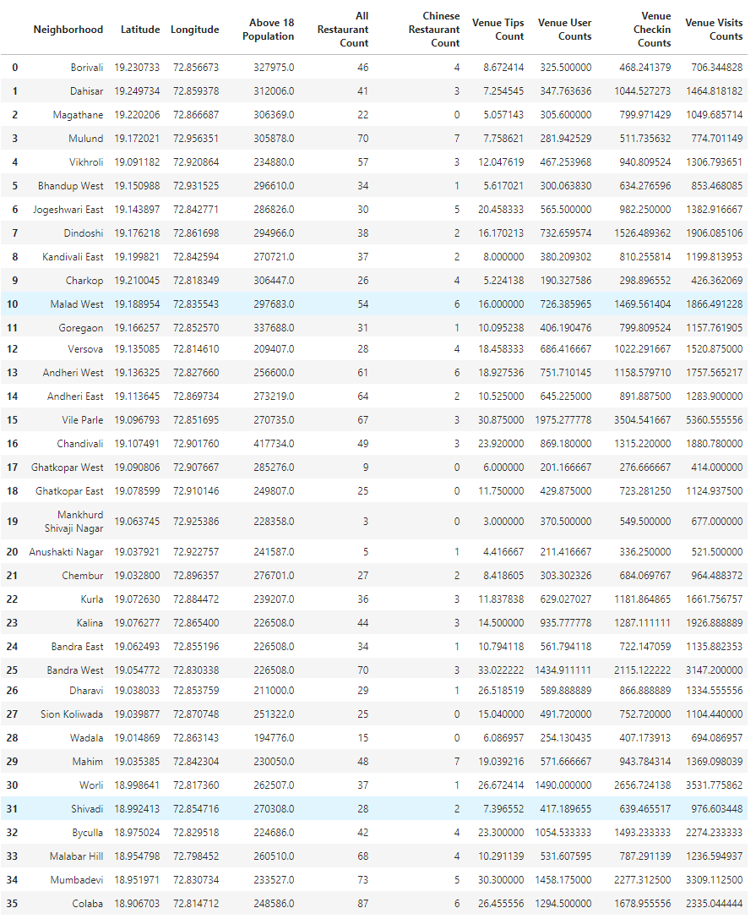

**Figure 8: Final Data**

#### Determine Number of Clusters

The number of clusters is determined by running the k-means clustering algorithm with k ranging from 1 to 11 and choosing the optimum value using the metrics: Silhouette Coefficient, Calinski-Harabaz Index and Davies-Bouldin Index. These metrics are used to evaluate a model where ground truth labels are not available as in our case since, we don’t have neighborhoods that are pre labeled with rank of choice for opening next Chinese restaurant. For a detail discussion of the aforementioned metrics please refer to <https://scikit-learn.org/stable/modules/clustering.html#clustering-performance-evaluation>.

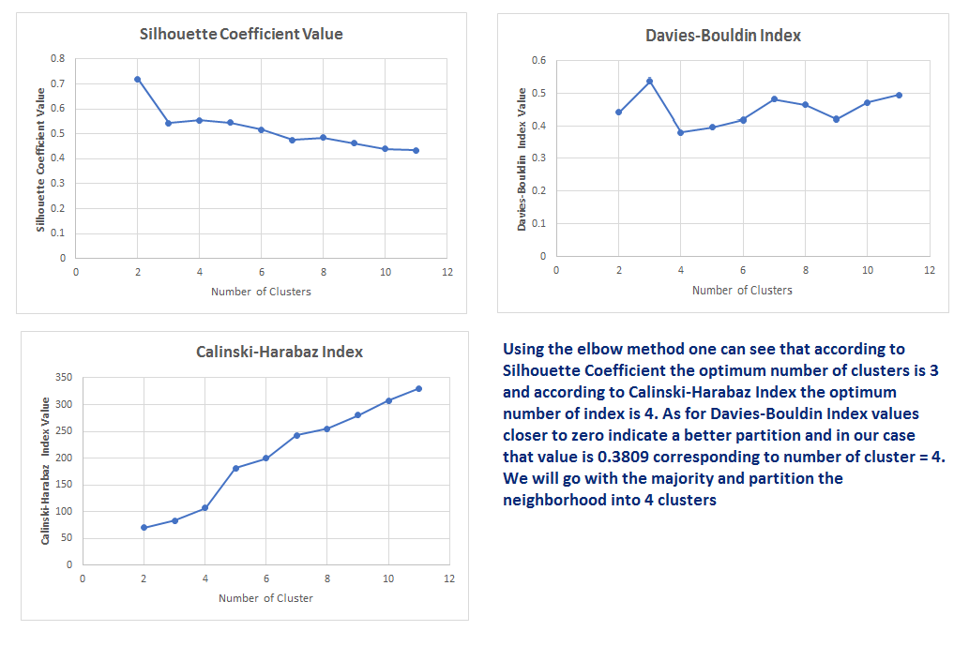

**Figure 9: K-Means Cluster Evaluation To Determine Optimal Number of Clusters Value**

From figure 9, using the elbow method one can see that according to Silhouette Coefficient the optimum number of clusters is 3 and according to Calinski-Harabaz Index the optimum number of index is 4. As for Davies-Bouldin Index values closer to zero indicate a better partition and in our case that value is 0.3809 corresponding to number of clusters = 4. We will go with the majority and partition the neighborhood into 4 clusters

## Results

#### The Clusters of Neighborhood

Using Number of clusters = 4, the neighborhoods were partitioned into 4 clusters using the K-Means clustering algorithm. The 4 partitions are as follows:

Cluster 1: Neighborhoods with more than 2 Chinese restaurants and moderate count values.

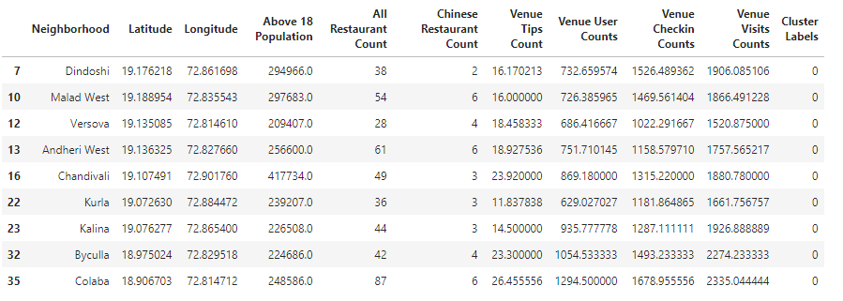

Cluster 2: All neighborhoods with no Chinese restaurants and moderate count values (on an average)

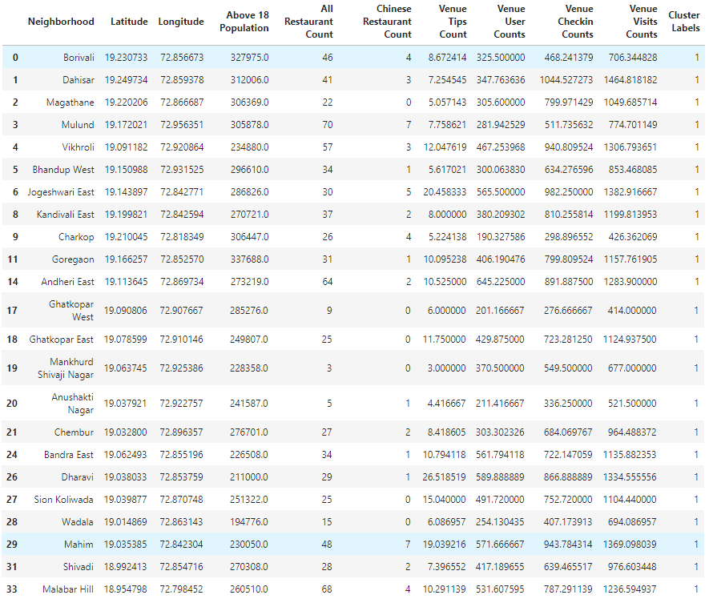

Cluster 3: Neighborhood with more than 1 Chinese restaurant and highest average counts.

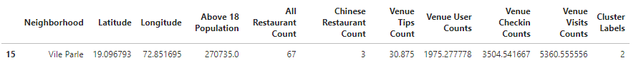

Cluster 4: Neighborhoods with high average counts, also containing a neighborhood with 1 Chinese restaurant

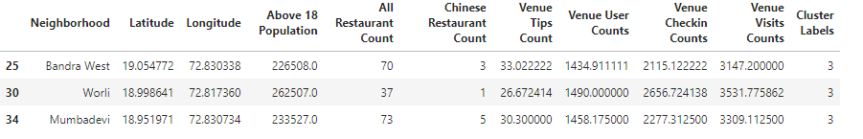

## Discussion

Data Exploration and Clustering both point to similar results for the next neighborhood for opening a new Chinese restaurant. These being

1. Ghatkopar East with no Chinese restaurant and good average counts (11.75 tip counts, 429.87 user counts, 723.28 check-in counts, 1124.93 visit count)
2. Goregaon with just 1 Chinese restaurant and good average counts (10.09 tip counts, 406.19 user counts, 799.80 check-in counts, 1157.76 visit count)
3. Worli, though not part of the same cluster as above two, but with only one Chinese restaurant and high average counts (26.67 tip counts, 1490.00 user counts, 2656.72 check-in counts, 3531.77 visit count) is also a good candidate.

As can be seen from figure 5 the Mumbai city has scope not only for Chinese but other authentic cuisine restaurants. An approach like this report can be taken for finding location for other authentic cuisine restaurants.

## Conclusion

Mumbai neighborhood data has been collected from Wikipedia and foursquare.com, analyzed and location for Chinese restaurant has been recommended using K-means clustering. Though the data is limited (eg. population data is about 18+ years only) the results are still good and usable.

Better data for parameters used for analysis in this report and data for other parameters mentioned in problem section would yield better results.

Mumbai city has good eating out crowd and hence has scope for other authentic cuisine restaurants. Approach like this report can be used for predicting other cuisine restaurants.